**EE66a Lab si3g19**

**Eddy Current Screening**

**3.1 Apparatus**

Simple example of eddy current screening, consisting of a copper (non-magnetic) tube inside a solenoid with a search coil on a moveable central support.

Second tube with axial slit 🡪 demonstrating when eddy current path is broken

Variable frequency supply 🡪 power function generator in series with variable resistor, to assist solenoid current adjustment.

Circuit current: 100mA 🡪 avoid distortion of sinusoidal waveform

* Why do you think the current will vary with frequency if the applied voltage remains the same?

Current varies with frequency

As self-inductance increases, frequency increases, the potential difference drops across the coil

Dimensions

a) Solenoid

Length = 280 mm

Approximate mean diameter = 110 mm

Number of turns = 664

b) Copper Tube

Outside diameter (2a) = 88.5 mm

Inside diameter (2b) = 82.5 mm

Wall thickness (t) = 3 mm

Resistivity () = 2.1 108 -m

**3.2 Experimental**

**3.2.1**

H0 : field at the centre of the solenoid without the copper tube

H1 : field with tube in position

Frequency: 20Hz-1000Hz 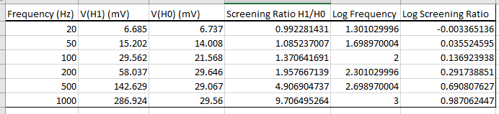

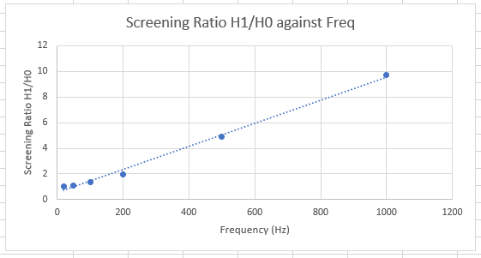 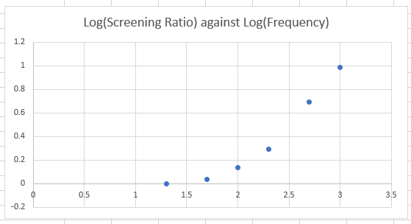

* Explain how does this voltage is related to the field inside the tube.

Voltage V is proportional to field

V=IR

$B=\frac{μ_{0}I}{2πr}$ $E= \frac{-dB}{dt}*\frac{r}{2}$

$E=\frac{-dI}{dt}*\frac{μ_{0}nr}{2}$

* Why the screening improves as the frequency increases?

As frequency increases, the rate of change of voltage across the coil increases. Therefore the rate of change of magnetic field increases and induces more current in the coil.

**3.2.2**

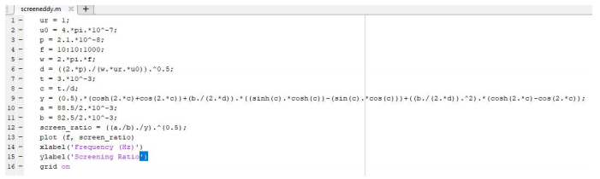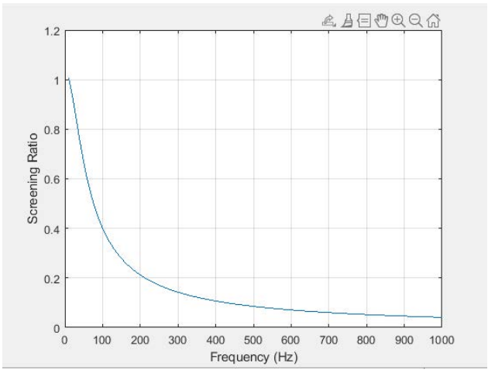

Using the matlab code, I saw that I got similar results. However, t must be remembered the tube is copper not aluminium.

* Compare experimental and theoretical values. Do you expect better of worse agreement if the tube outer and inner radii are reduced by factor of 10?

Expect my results to fit worse because t<< a. so reduces t by a factor of 10. Reduces difference by a factor of 10. This means that t will be closer to and the approximate value will be less accurate.

**3.2.3**

Constant Frequency: 300Hz

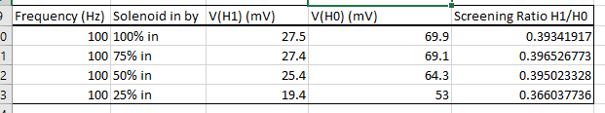

* Explain the dependence of the fields H0, H1 and the screening ratio on the position.

Screening ratio stays relatively the same

Somewhat constant, no dependence

**3.2.4 Split copper tube**

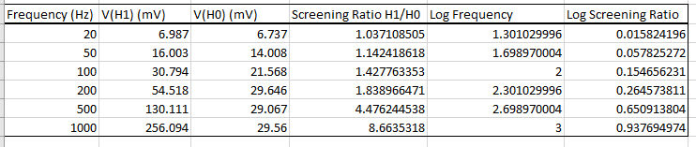

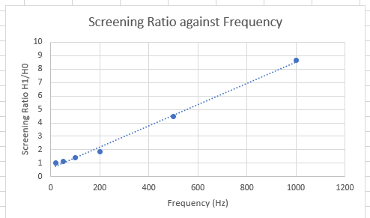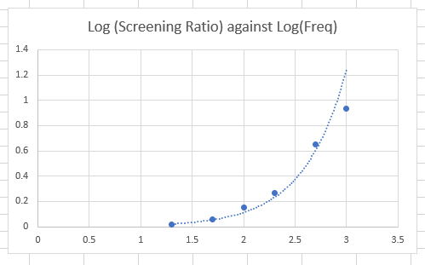

Constant Frequency: 300Hz

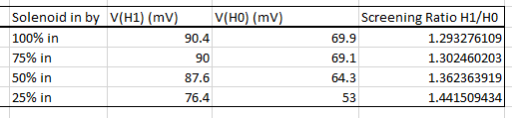

* As expected, the screening is very bad. Why?

Screening is very poor as there is a gap in the solenoid. The eddy currents which were previously free to flow around the complete tube are now unable to as the path is broken by the slit

There would be another magnetic field created in the slit.

* What happens near the end of the tube?

The field strength decreases

**3.2.5 Cut copper tube**

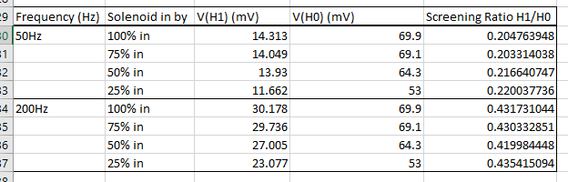

**3.3 Theoretical consideration**

$$={(\frac{2 }{ _{r}{}_{0}})}^{1/2}$$

$$\frac{H_{1}}{H_{0}}=\sqrt{\frac{a/b}{Y}}$$

$$c=\frac{t}{}$$

$$Y= \frac{1}{2}\left(\cosh\left(2c\right)+\cos\left(2c\right)\right)+\frac{b}{2}\left(\sinh\left(c\right)\cosh\left(c\right)-\sin\left(c\right)\cos\left(c\right)\right)+{\left(\frac{b}{2}\right)}^{2}(\cosh\left(2c\right)-\cos\left(2c\right))$$